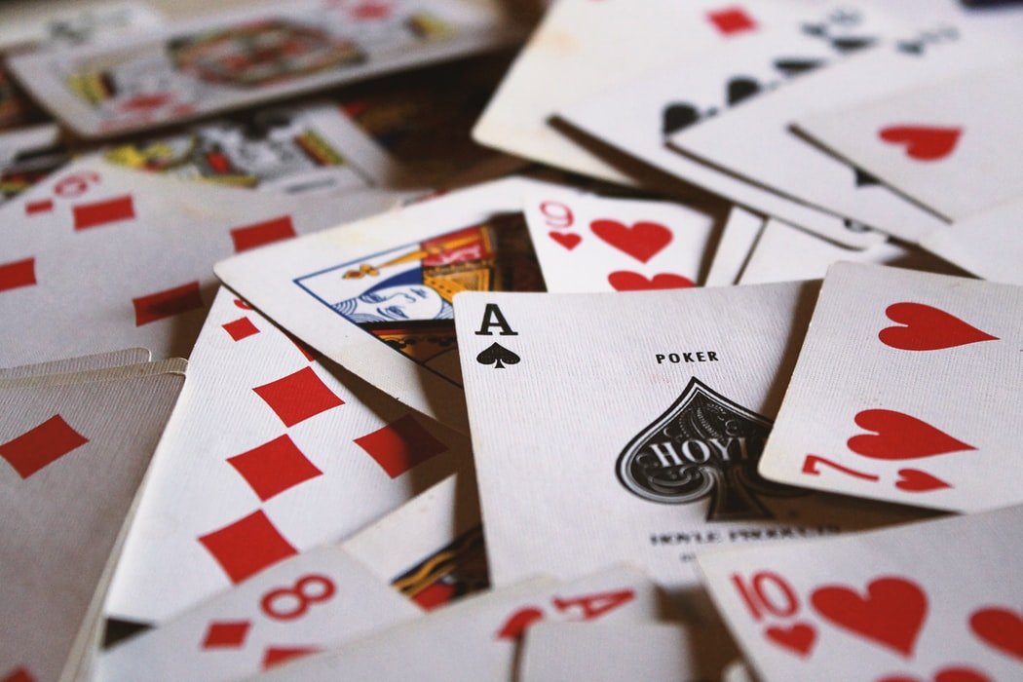

|  |
| --- |
| Durak  User Guide |
|  |
| April 17, 2020  OOP 4200  Group 3  Authored by: Anastasiia Kononirenko  Andrew Rocha  Harry Palmer  Natan Colavite Dellagiustina  Professor: Thom MacDonald |



Table of Contents

What is Durak? 3

How to play Durak? 3

The Game Screen 4

The First Gamestart 5

Defend 6

Attack 7

End of Game 8

# What is Durak?

Durak (Russian: дурак) is a popular Russian game that is played in a lot of post-Soviet countries. “Durak” is a Russian word for a fool. In this game, the fool is the loser or a player who is left with cards at the end of the game.

There are different types of Durak; the most popular ones are Podkidoy Durak and Perevodnoy Durak. The game is typically played with between two and six people. Our game is a traditional Durak that you play against a computer.

# How to play Durak?

Please follow the link below to read the game’s rules:

[Rules Of Durak Card Game](https://www.gamblersbet.com/encyclopedia/rules-durak)

# The Game Screen

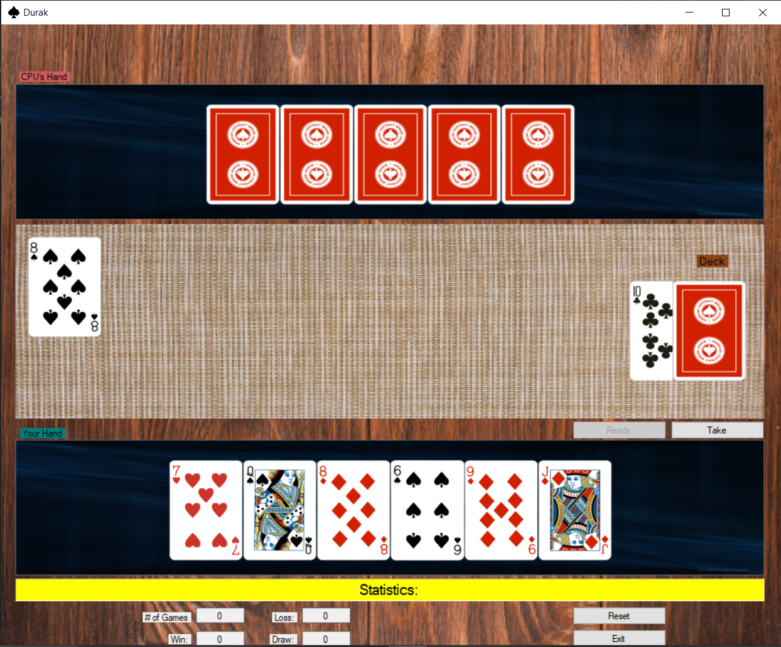

The Game screen includes:

* Computer’s panel with all cards being face down (CPU’s Hand)
* Main play area with a deck of cards and a card that defines the Trump suit on the right
* A Ready button that a player clicks when they want to stop attacking
* A Take button that a player clicks when they want to pick up cards from the play area
* Player’s panel with all cards being face up (You Hand)
* Statistics which includes:
  + Number of games played
  + Number of times player won
  + Number of times player lost
  + Number of times game ended in a draw
* A Reset button that a player clicks when they want to start a new game
* An Exit button that a player clicks when they want to exit the game

# The First Gamestart

(Refer to the image above)

When the game loads for the first time:

* Both players have 6 cards in their hands
* Game determines who is going to attack first:
  + If there is a card in the main player area, it’s computer’s turn to attack
  + Otherwise, it’s player’s turn to attack

# Defend

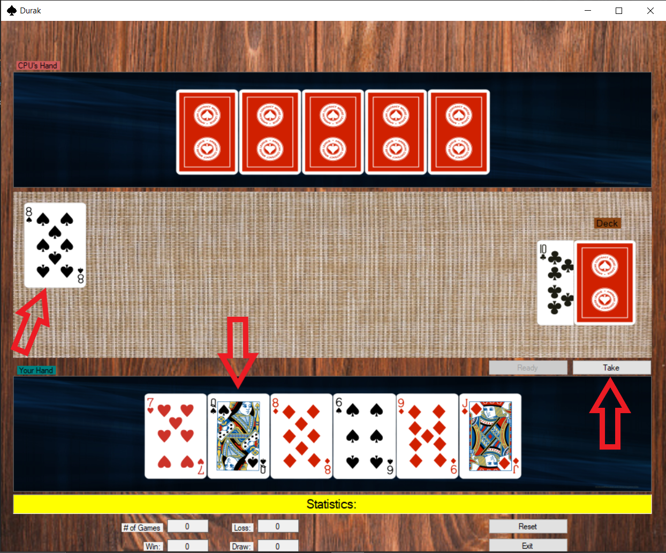

If there’s a card in the main play area, it’s your turn to defend:

* Drag and drop the card you want to defend with
* Game will not let you drag a card that can’t beat computer’s card
* If you either don’t have a card that can beat computer’s card or you want to take cards from the table, click on Take button

# Attack

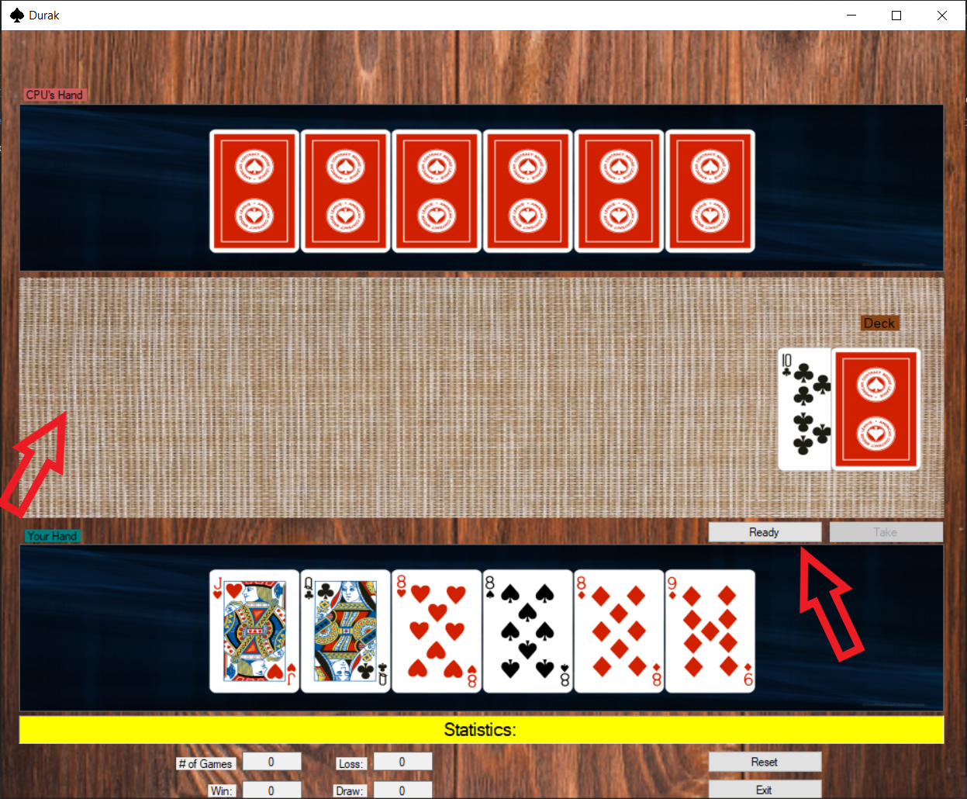

If there are no cards in the main play area, it’s your turn to attack:

* Drag and drop the card you want to attack with
* If you either have no more cards to attack with or you want to stop attacking, click the Ready button
* Clicking the Ready button without attacking will not do anything

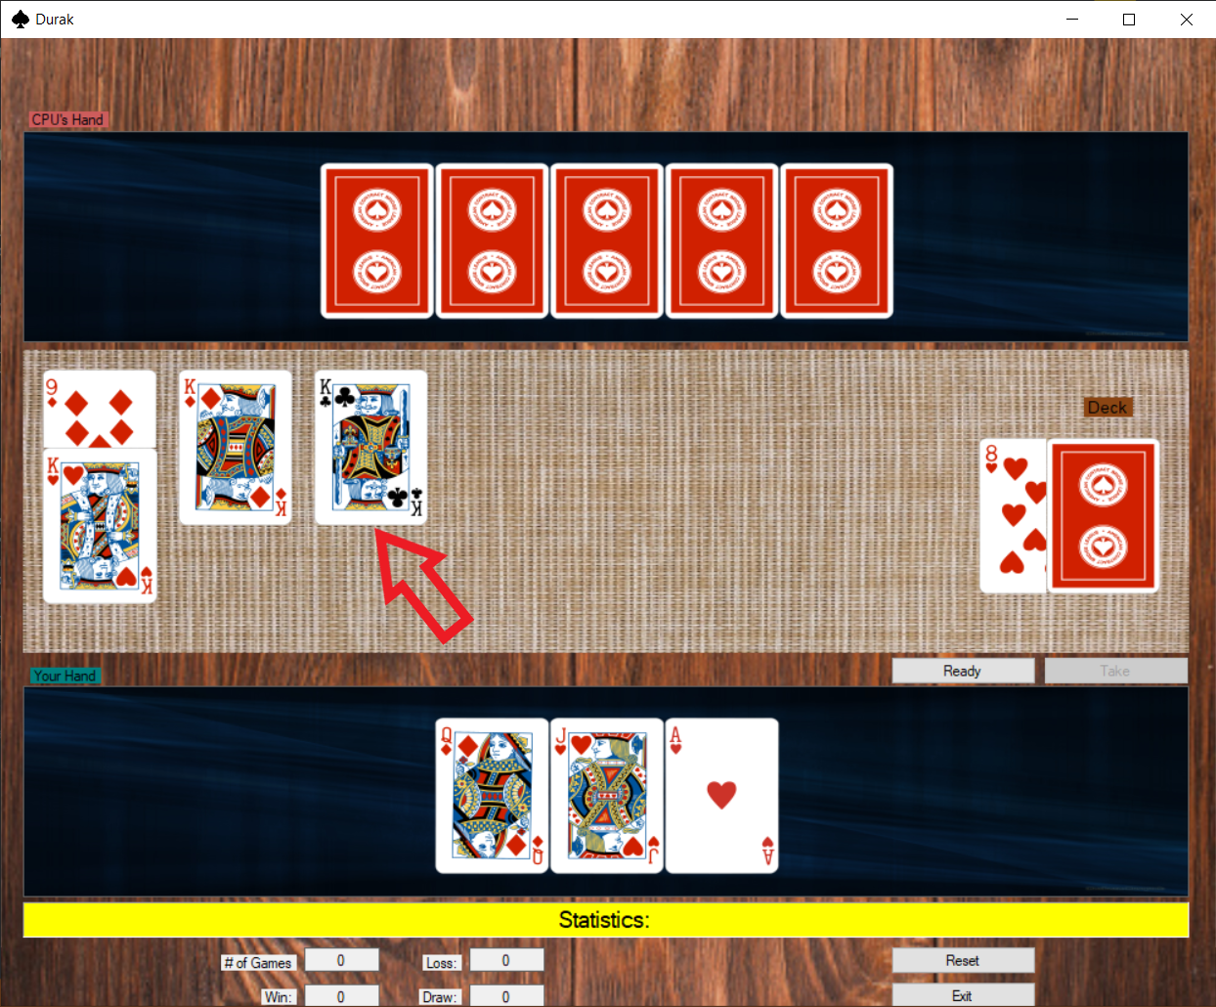

If computer decides to take the cards, you can still add more cards before clicking Ready.

# End of Game

When one of the players has no cards or both players have no cards, the game ends. There are three possible results:

* You win

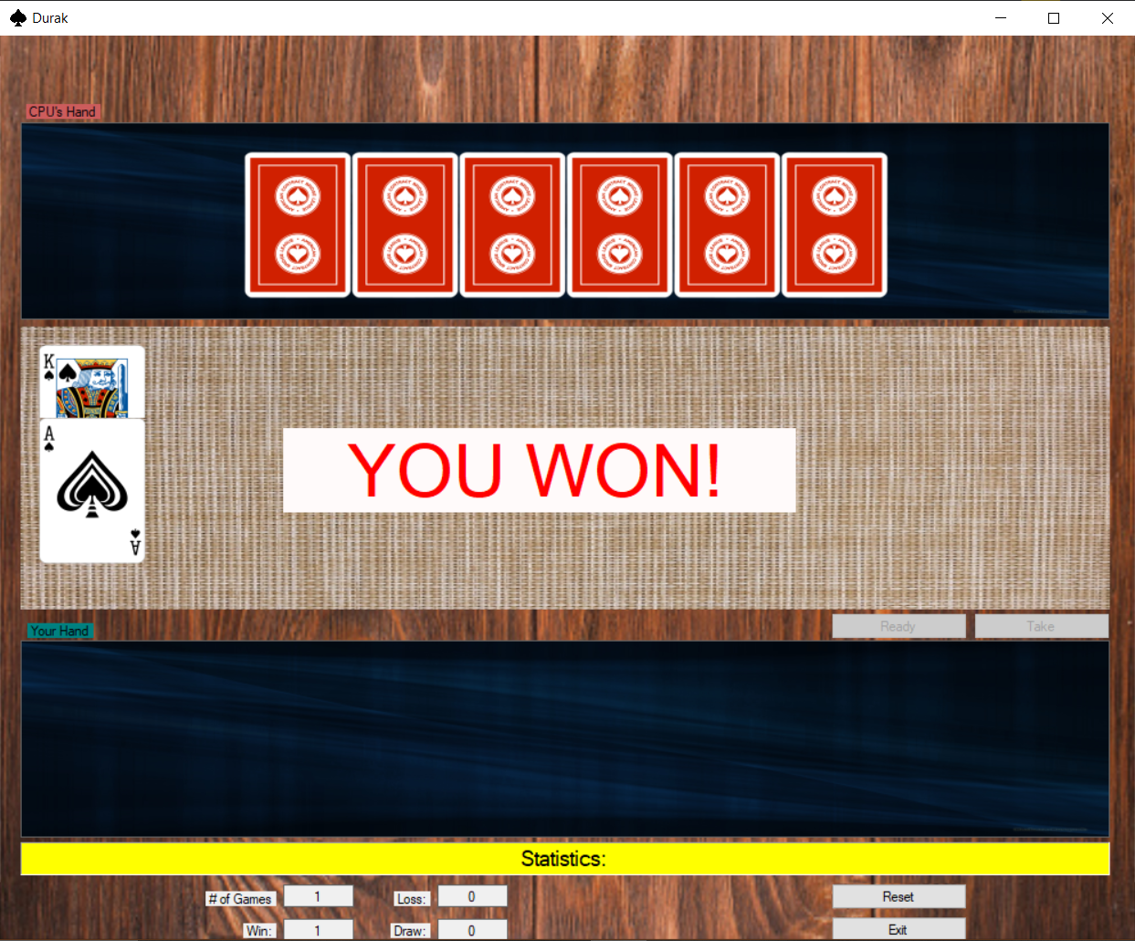

* You lose

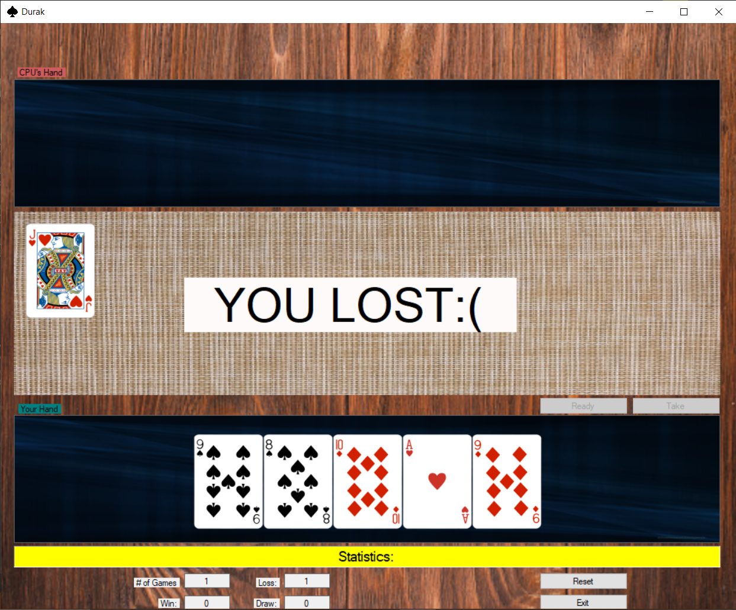

* Game ends in a draw